**PROXMOX INSTALLATION AND CONFIGURATION**

1. **Download ISO of Prox-mox**

**URL -** [**https://www.proxmox.com/en/downloads/category/iso-images-pve**](https://www.proxmox.com/en/downloads/category/iso-images-pve)

1. **Download - usbimanager for make bootable pendrive**

**URL - https://gitlab.com/bztsrc/usbimager/-/tree/master/**

1. **Link usbimager –**

**https://gitlab.com/bztsrc/usbimager/raw/binaries/usbimager_1.0.9-i686-win-gdi.zip [For windows]**

1. **VIRTUALIZATION ENABLE**

**BIOS --> Advance --> CPU configuration --> Virtualization = Enabled**

1. **Install PROXMOX from which we have created a bootable Pendrive.**
2. **URL -** [**https://IP:8006**](https://IP:8006) **[LOGIN FROM Favourite Browser]**
3. **Create storage as Directory.**
4. **ISO upload**
5. **Make a new instance.**

**# First let’s create storage as directory**

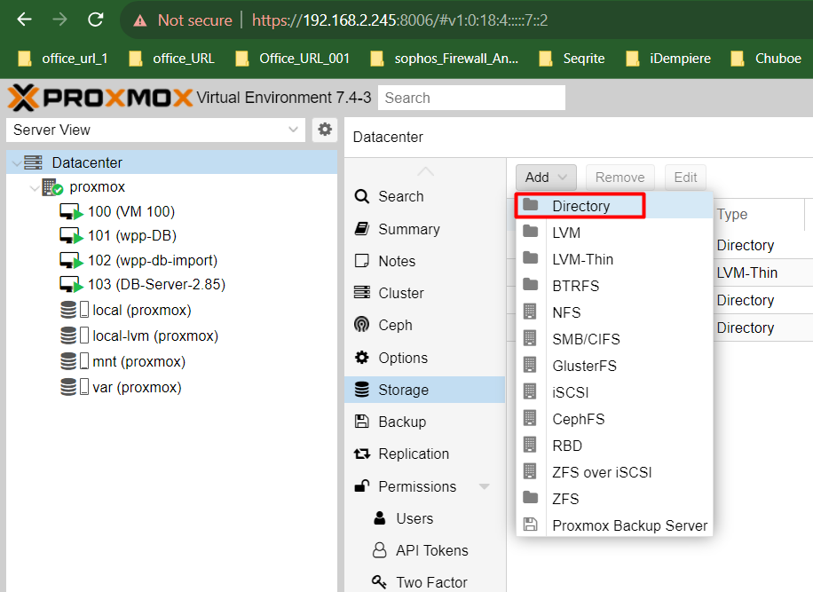

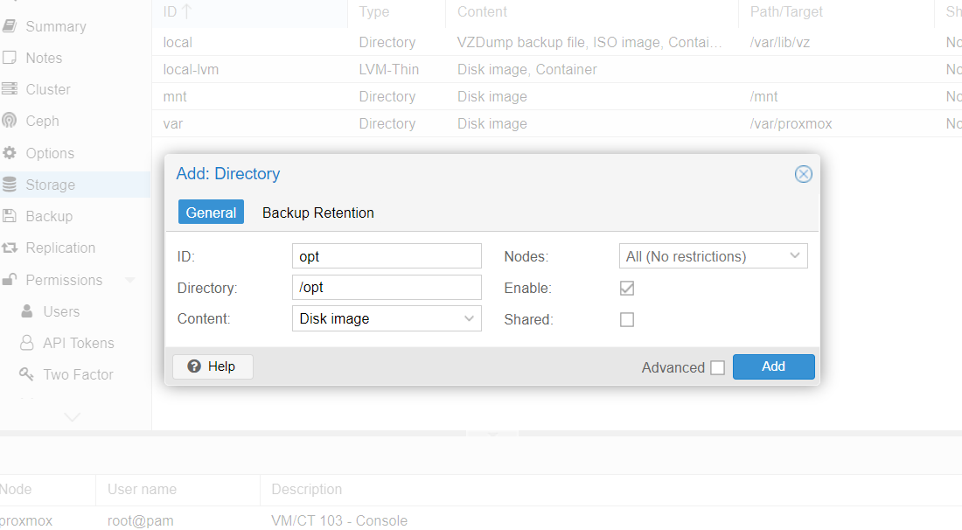

**# ISO upload. We have Two options to upload 2 sides from the browser and server-side.**

1. **Server side**

**cd /var/lib/vz/template/iso**

**upload ISO file on this path.**

1. **From Browser**

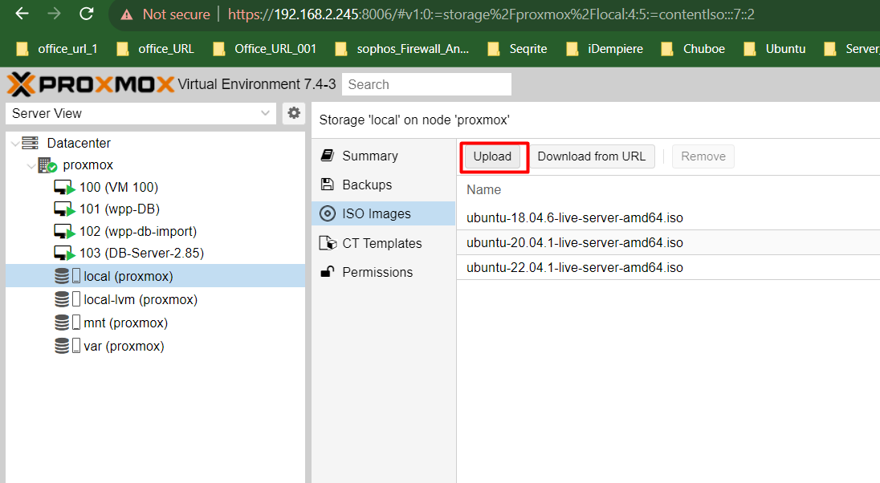

**# Let's create a new Instance**

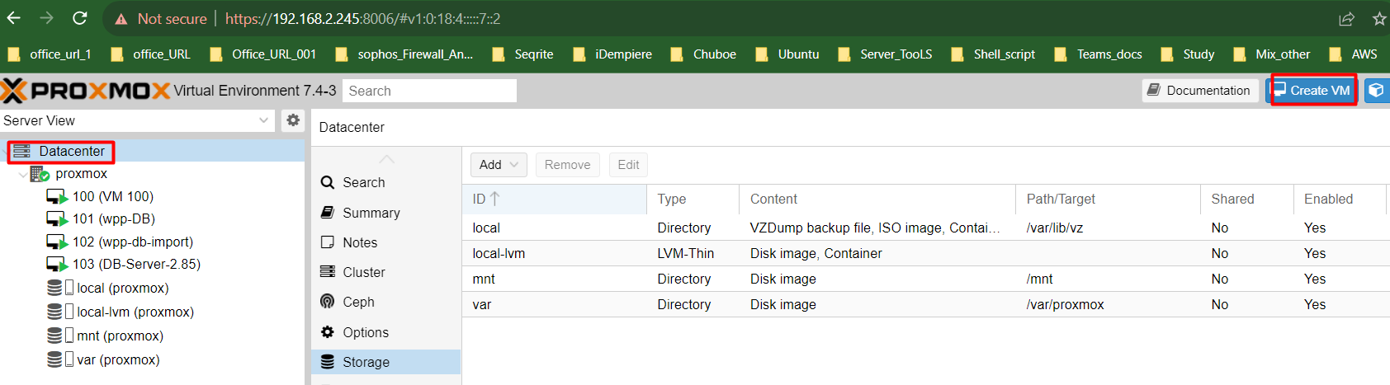

**# First Provide Instance name.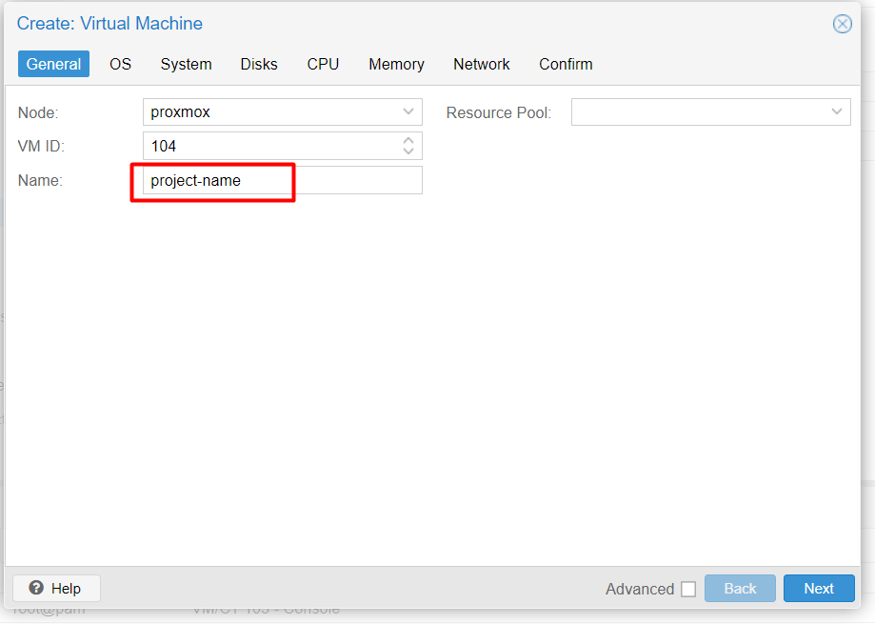# Select OS which we have to install**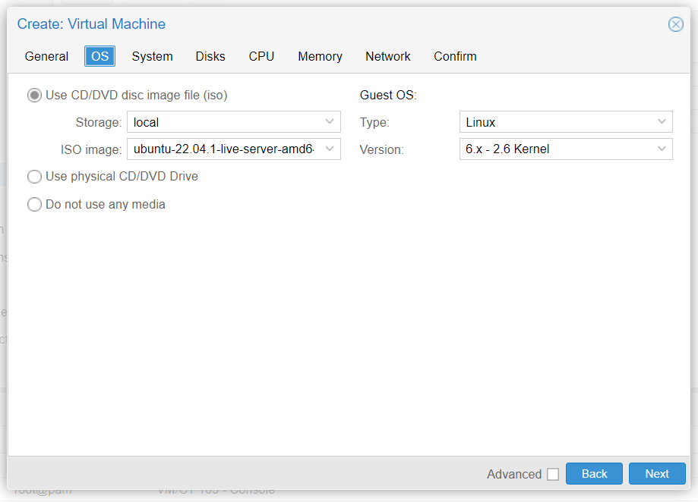

**# Select default.**

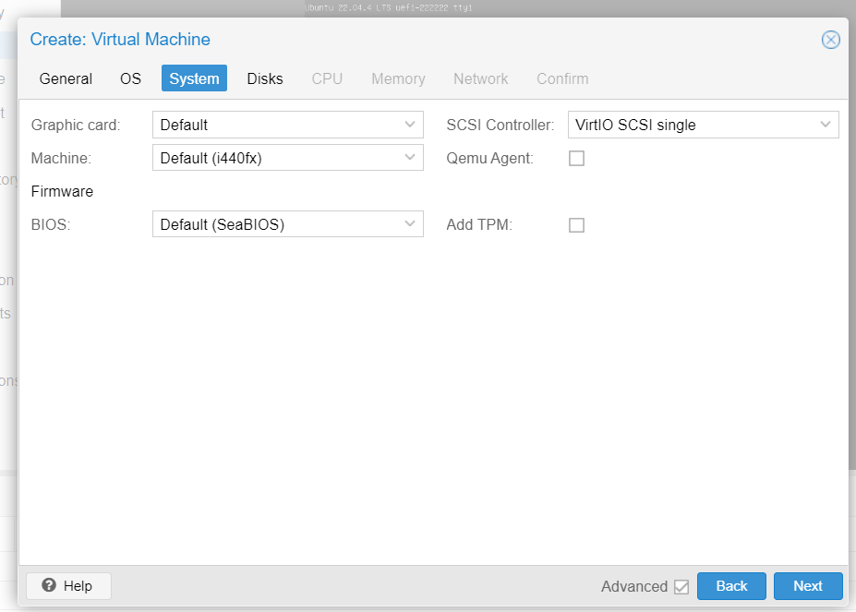

**# Here we are select bus/device SATA and provide storage and Disk size as per our requirement.** 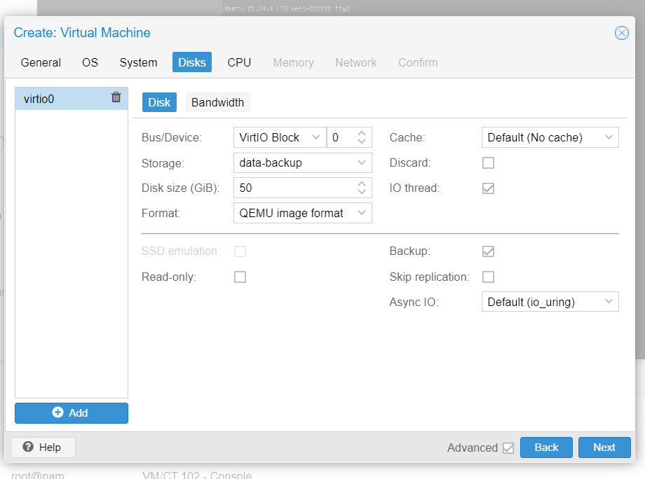

**# Now we are going to provide CPU [core] as per our need.**

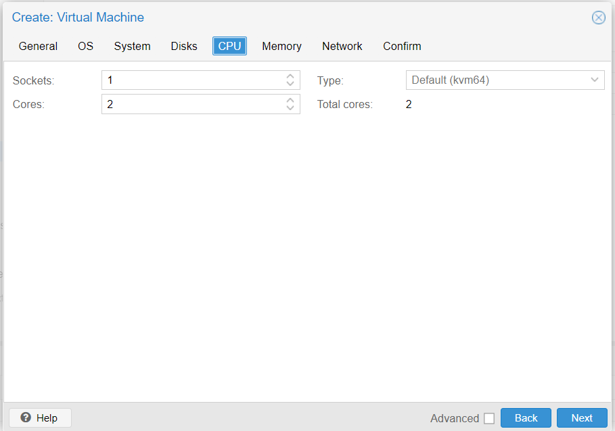

**# Here we have to provide RAM [memory] which we need on instance.**

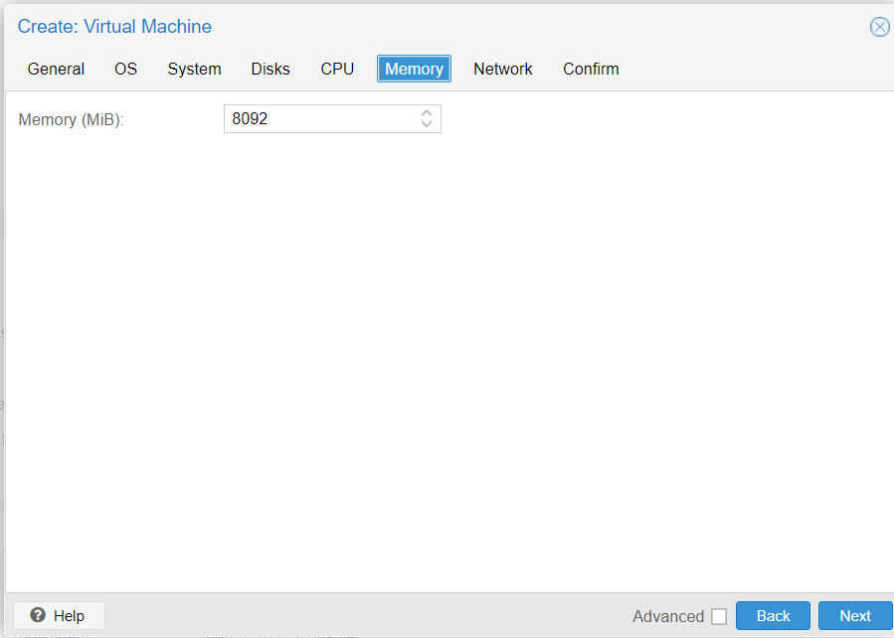

**# Network – we are using bridge network.**

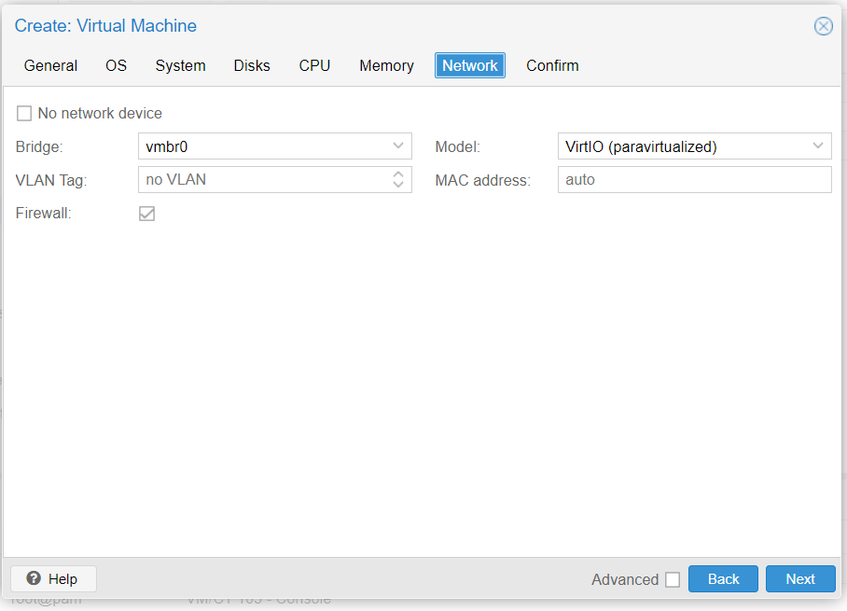

**# Validate our configuration and finish it.**

**# Now start the instance and complete the OS installation steps.**

**Done!**

**# How to add storage on Proxmox.**

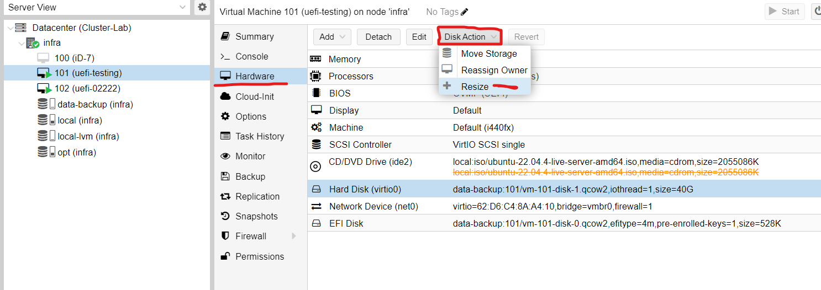

**The current size is 50 need to add 20.**

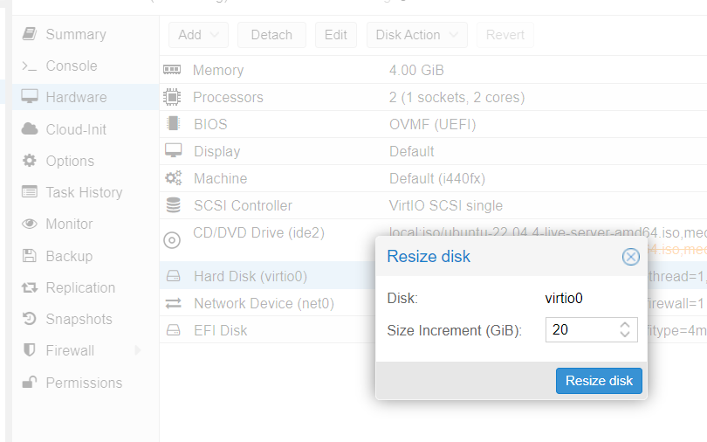

**# Now just need to run below command for grow partition.**

**sudo growpart /dev/xvda 1**

**sudo resize2fs /dev/xvda1**

**# verify**

**df -h**

**Made by IV**